CROSS-REFERENCE TO RELATED APPLICATIONS AND PRIORITY

[001] The present application does not claim priority from any patent application.

TECHNICAL FIELD

[002] The present invention matter described herein generally relates to a biomechanical wrist joint that mimics the human wrist joint motion and spherical actuation. The mechanism consists of four Linear actuators which are connected in parallel. By actuating the two Linear actuators, the end-effector could produce the maximum degree of motion of 180 degrees. Using four actuators correspondingly the spherical actuation can be produced. The system works in the principle of a closed-loop control system where encoders are used for precise position control and speed control using PID. Arduino Uno is used as a microcontroller.

BACKGROUND

[003] The wrist joint consists of eight carpal bones that make up the hand and are divided into two rows: proximal and distal. The scaphoid, lunate, triquetrum, and pisiform make up the proximal row of carpal bones (which run from radial to ulnar), whereas the trapezium, trapezoid, capitate, and hamate make up the distal row of carpal bones. These bones make up the majority of the wrist's skeletal skeleton and enable tendons and other neurovascular pathways to access various muscle groups and bony structures.

[004] Generally, the Biomechanical wrist joint is not considered in making the commercial prosthetic arm, and the degree of freedom is less than the human wrist joint. This is because the complexity of producing motion of the human wrist joint is high and the mass(weight) consideration is to be accounted for it.

[005] Overall, the complexity of the design and manufacturing of biomechanical wrist joints that can produce 3 degrees of freedom can vary depending on the specific mechanism used and the materials and processes involved. They require a high level of expertise and precision to manufacture, which can result in a higher cost of production. However, these advanced designs provide a high level of functionality and control for users, making them a valuable option for prosthetic arm users who require a high degree of dexterity and control.

OBJECT

[006] The present invention has an object for assisting a prosthetic limb which gives more flexibility to the wrist joint of the limb using a parallel actuator mechanism and aims to overcome the limitations in biomechanics. The wrist joint motion is mimicked by using a parallel actuator and the actuator is coordinated and controlled by the closed-loop control system. The encoder is used to get the precise position feedback and for motion control, PID is used to correct the error actuator and coordinate the wrist motion.

SUMMARY

[007] This disclosure of the present invention discloses a prosthetic wrist joint that mimics the human wrist joint motion and could produce spherical motion too. The device can be used for the prosthetic limb. And this device can be used in other robotic applications too where we need 3 DOF for the end-effector. This design and control were analyzed and tested for multiple scenarios to find the best performance.

BRIEF DISCUSSION

[008] The invention disclosed has a specific application and it can be used in multiple applications. Where multiple degrees of freedom motion is required. The invention is a prosthetic wrist joint. The invention focuses on the end motion produced by the wrist joint. Prosthetic wrist joints in market functionality differ, and commercial prosthetic arm has one DOF. The prototype can produce motion in 3DOF, which is precisely measured and corrected using a PID controller so any error in the motion is rectified instantly. For control, four microcontrollers (single-core controllers) are used by Arduino Nano.

DETAILED DISCUSSION

[009] The spherical motion of the prototype is achieved using a parallel Linear Actuator (figure 1) which produces a tilt motion of 180 degrees by co-ordinately actuating the two pairs of linear actuators we can attain three degrees of freedom.

[008] The Linear Actuator is driven by an N20 Dc motor mentioned in (figure 8) within the built encoder which uses a hall-effect sensor to measure the position.

[010] Each actuator end-effector or connected to the universal joint (figure 7) which makes the three degrees of freedom.

[011] To attain the linear motion the lead screw and brass nut (figure 2) is used when the motor rotates the screw the brass nut lifts the end-effector (figure 3) of the linear actuator. Then the actuators are connected by the linear actuator mount (figure 5)

[012] The Linear actuator is connected by a frame (figure 4) that holds the device structure and the frame is connected to the base mentioned in(figure 8).

[013] Actuators are connected by a universal joint mentioned in (figure 7) which is then connected to a prosthetic arm(end-effector).

[014] The four linear actuators are controlled by a microcontroller called Arduino Nano. Each actuator has a purpose to control one actuator’s position and speed by coordinating four actuators the spherical actuation is created.

[015] As far as motion consideration the actuator initial position of the linear actuator should be from the middle or end of the actuator length (figure 3) so that the spherical motion can be achieved. The input is given via a potentiometer and can be changed per the requirement.

[016] Each actuator is Controlled by a PID controller, reducing the chance of error, and making it easier to achieve the precise position and more reliable.

CLAIMS

[017] A novel three-degree freedom spherical actuator for the motion of wrist joint, comprising of:

1. spherical actuator produces three degrees of freedom to drive the arm.
2. Parallel actuators drive the load to 180 degrees.
3. Potentiometer module for the input signal to the linear actuator.
4. It has a precise position control using PID.
5. Universal Joint(101) connects the Linear actuator(102) to produce spherical motion.

[018] A device as claimed in claim 1, produces a spherical motion of three degrees of freedom for the wrist joint and a normal range of motion for the wrist joint (flexion, extension, abduction, and adduction).

[019] A device as claimed in claim 1, wherein provides motion control and speed control using PID control, and the four linear actuators are coordinately controlled to achieve spherical motion.

[020] A device as claimed in claim 1, wherein the potentiometer gives input to the linear actuator for linear motion.

[021] A device as claimed in claim 1, wherein the universal joint (101) connects the linear actuator to produce spherical motion.

[022] A device as claimed in claim 1, wherein position control is done using PID control where an encoder is used gives feedback to the microcontroller to rectify the error.

ABSTRACT

[023] A novel spherical actuator for the motion of the wrist joint device is designed to produce three degrees of freedom. This device comprises four DC N20 motors (103) with an encoder, four linear actuators (102), 2 Arduino Nano, a universal joint (101), and a potentiometer for input. The input signal sends via a potentiometer then the microcontroller commands the parallel linear actuator to move in the opposite direction by creating a 180-degree motion and by actuating the two pairs of linear actuators at the same time three degrees of motion are created. If any error in position is rectified by the PID controller to attain a precise position. Overall, this device has the potential to be used in any application where three degrees of freedom are required.

DIAGRAM/IMAGE/FLOWCHART

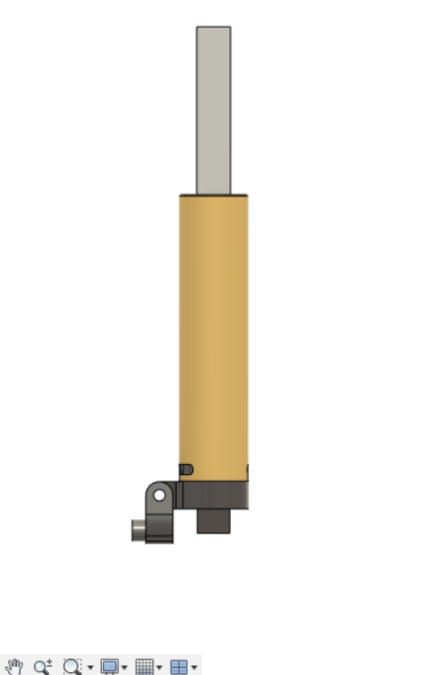

Figure 1(Linear Actuator)

Figure 2(Lead Screw and Brass Nut)

Figure 3(Leads Screw connected to end-effector)

Figure 4(the frame which connects the linear actuator)

Figure 5(Linear Actuator Mount)

Figure 6(The Universal Joint connected to the frame)

Figure 7(Universal Joint)

Figure 8